Cardiopulmonary bypass
Diagram by Art Wallace, MD PhD
www.cardiacengineering.com
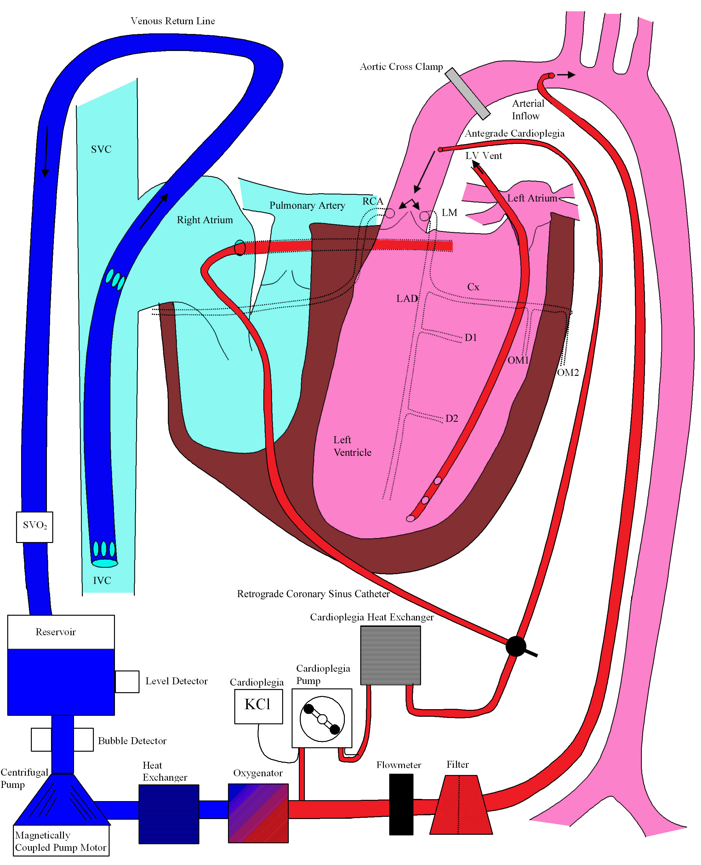
Copyright 2005 Art Wallace MD PhD
www.cardiacengineering.com

